Instructions for installing a client-server application based on WCF for a ISD test

# Server installing

The first step is to install the service. Use the installation file “Service.Host.Installer”, attached to the instructions.

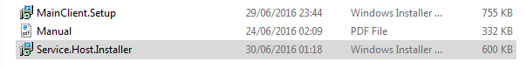

Run and follow the instructions. Upon completion of the installation is required to run the service.

To run the service restart your computer or run the service manually.  
Go to “Task Manager” in tab “Services”. In the list, locate our server “MainHostService” right-click it and press “Start”. All logs will be saved at “System32\winevt\Logs” in “MainServiceLog.log”.

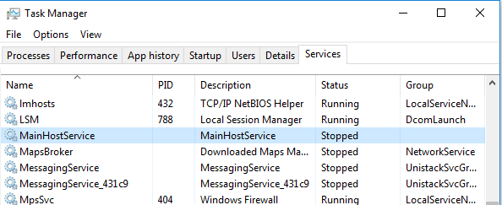

# Client installing

The second step is to install the client. Use the installation file “MainClient.Setup”, attached to the instructions.

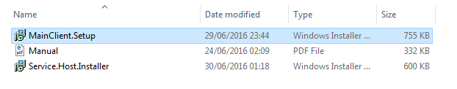

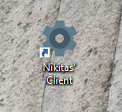Follow all instructions, chose a costume path for application directory. After completion of the installation run the application from shortcut on desktop

Finally, sing in with login: admin, password: admin, chosen IP address and connection type.

